Using WPF for Good and Not Evil
By David S. Platt
Head Honcho, Rolling Thunder Computing
Introduction
Forests of trees, oceans of ink, galaxies of innocent electrons, have been slaughtered in order to show application designers how to program this or that feature of WPF: how to program a color gradient, for example, so the color transitions smoothly from one value on one side of the window to another value on the other side; how to animate an item, to make it move while the user watches in spellbound admiration; how to alter the appearance of a control without altering its behavior, and so on.
Far less has been written about what should be done and what shouldn’t, or when something should be done and when it shouldn’t, let alone why. Animation is now easy, but where and when does it enhance a user’s experience and where and when does it degrade it? Under what circumstances do color gradients help or hinder a user’s perception of information? The attention given to how overtops the attention given to what and where and when and why by a factor of at least 100. And that’s wrong.
WPF is more powerful than Windows Forms, as a chain saw is more powerful than a hand saw. This increased power allows you to accomplish more useful work. However, it also increases the need for great care in employing the powerful tool. You can’t hurt yourself too badly with a hand saw compared to what you can do with a mishandled chain saw. I see enormous exultation over the power of WPF, and the exulters are absolutely correct about the magnitude of that power. I see darn near zero discussion of the careful thought needed to safely and productively manage that power to make users happy, which is the final result that we care about accomplishing. This paper is my attempt to lay out the fundamental principles and begin that discussion.
Sample Application
This white paper examines the Family.Show (hereafter FS) genealogy sample application, shown in Figure 1. This is a reference sample application commissioned by Microsoft and written by Vertigo Software to showcase the capabilities of WPF. The application and its source code are online at http://familyshow.codeplex.com/ . For “how-to” advice, it succeeds quite admirably.

Figure 1 Family Show Application
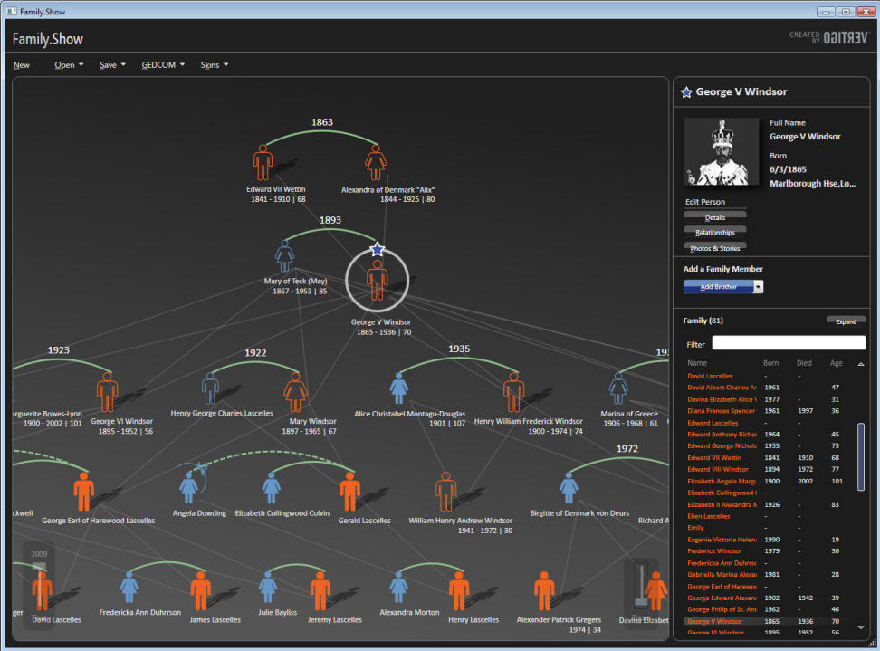
FS was written from the technology outwards, not from the user inwards. As Vertigo’s CEO said in a Channel 9 interview, “Let’s take some new technology and find a business problem.” As you will see, FS uses some new features of WPF to accomplish wonderful things that make the user happier than he would have been before WPF. As you will also see, FS uses the exact same features to accomplish some not-so-wonderful things that make the user less happy than he would have been before WPF. The same feature of WPF is used both for good and for evil in the same application. In a way, that makes FS an even more valuable demonstration program that it would otherwise have been.
Three Fundamental Principles
I majored in physics as an undergraduate, and there’s still enough of the physicist in me to insist on setting forth the fundamental principles from which I derive my judgments as to good and bad usage. I judge what is good about an application and what is bad by applying the following three principles, which I call Platt’s Programming Principles (P³) :
First Principle: That the software that you write has zero value in and of itself. You write software for one reason and one reason only: to create value by making the user of your software happier than he would be without your software. The only value that your software ever has or ever will have is the degree to which it increases the happiness of its users. It is extremely rare that users spend money for software that decreases their overall happiness. [Don’t touch that line.]
Second Principle: That computer programs increase the happiness of users in one of two ways. The majority of applications help a user solve a specific problem – writing an email message or an article, buying groceries or an airplane ticket, viewing a bank statement and paying bills. The user’s only goal in using this type of program is to finish the task and get on with his life, or at least on to the next task. The faster a program converts a task from not-finished to finished, the happier the user will be. Completing a task in 10 minutes is better than 11 minutes, and 9 minutes is better than 10. Examples of this type of application are Microsoft Office, Visual Studio, and Money.
The second way in which a program increases a user’s happiness, less common than the first, is by putting the user into a pleasurable state that he wants to maintain as long as possible, or at least as long as it remains pleasurable. Games fall into this category, as do media players. My favorite example of this type of application is Skype, with which my daughters (ages 6 and 9) make video phone calls to my parents.
Third Principle: That in neither of these cases do users want to think about the programs they are using. At all. Ever. In the former case, they want to think about the problem they are solving: the wording of the document they are writing, or whether they have enough money to pay their bills, and which unpaid creditor would hurt them the most. They don’t want the program to distract them from the problem they’re thinking about. If they want to goof off and waste time, they’ll bring up Solitaire, not admire the flashing video buttons in the word processor. In the latter case, the users want to get into that pleasurable state as quickly as they can and stay there as long as they can. Anything that delays the start of their fix, or distracts them from it while they’re enjoying it, is even less welcome than the interruption of a work task. My parents want to see and talk with and gush over their grandchildren, and my children their grandparents. Any attention that the program diverts from this purpose to itself is a negative.
To summarize these three principles: Users doesn’t care about your program in and of itself. Never have, never will. Your mother might, because you wrote it and she loves you, and then again she might not; but no one else does. Users care only about their own productivity or their own pleasure. Every single user of every single program wants what Donald Norman calls The Invisible Computer, in his landmark book of that title. With these principles in mind, let’s go examine Family.Show.
Color Gradients
The human eye can discern and the human mind can quickly integrate an enormous amount of information from different shades of color. Figure 2 shows a superb example, Princeton Professor Robert J. Vanderbei’s map of the US presidential election results from 2004, which uses color gradients to express popular vote percentage by county ^{[3]}. Complete red indicates 100% Republican, complete blue is 100% Democratic, and a smooth mix of the two represents intermediate percentages. You can see, for example, that California’s coastline is highly Democratic but its interior is much more Republican. The Texas Panhandle is red but the Rio Grande Valley is blue, with a small blue enclave around the state capital of Austin, and so on.
Figure 2 Purple America, 2004 Presidential Election, by Robert J. Vanderbei. Used under Creative Commons license.
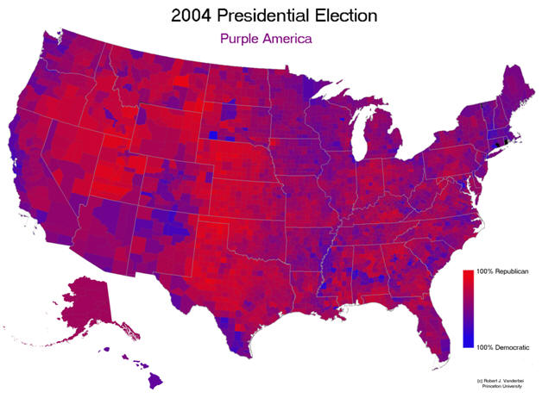
The right side of your brain absorbs this information very, very quickly, in parallel, as it were. It’s a mainline into the depths of your mind. If you had read these numbers from a list and thought about them rationally with the left side of your brain, you couldn’t integrate anywhere near as much information anywhere near as quickly. Presenting information in this way is fundamentally different in kind, not just in degree, from the left-brain way.
Now that I’ve demonstrated the immense leverage that this simple pattern exerts on a user’s brain, it shouldn’t surprise you that sometimes color gradients get used well and make the user happier, and other times they backfire and accomplish the opposite. Let’s look at the use that FS makes of color gradients.
The family tree view (the left panel in Figure 1, close-up shown in Figure 3) contains a vertical color gradient. It’s darker at the top and lighter at the bottom. This is an excellent use of a color gradient, a poster child for demonstrating what gradients do well and the correct time and place and manner in which to use them. As the user’s eye moves from the top of the page to the bottom, the background color doesn’t just change, it progresses in a way that the user’s right brain instinctively understands. This indicates to the user that the data displayed on that background progresses in some meaningful way, which it does – earlier generations are at the top of the screen, later ones at the bottom. Furthermore, the dark shade at the top indicates the dark of the past, and the lighter shade at the bottom indicates the light of today. In a subconscious, right-brain way, the program is telling the user the axis along which data progresses (vertical), and the direction of that progression (later is down, earlier is up). See how many words it took me to explain to your left brain what your right brain instinctively deduced from the color flow? And it’s still not as effective.

Figure 3 Close-up of Family Tree View
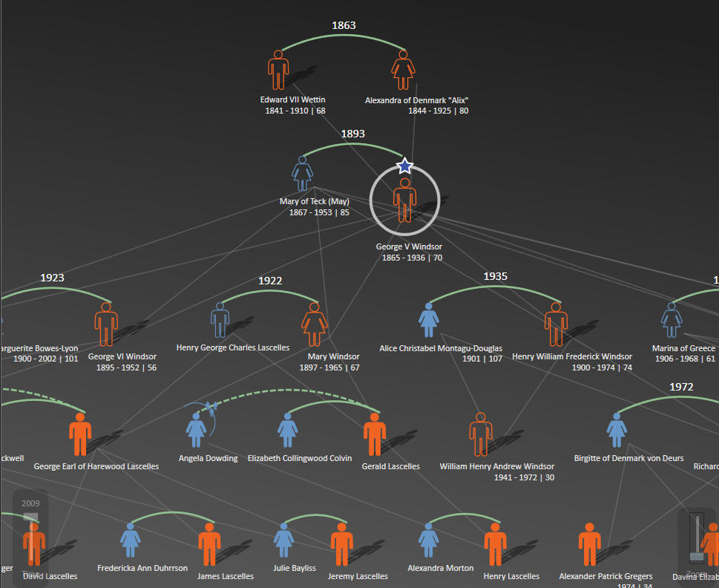
The gradient presents the idea at first glance and then reinforces it with every scan of the user’s eyes. This gradient is not a mere stylistic element, it enhances the user’s experience in an important way by explaining the program’s layout to the user’s subconscious mind. The user feels more comfortable, more at ease with the application. He probably won’t know why, and he certainly shouldn’t have to think about it; but it makes him happier and more productive and therefore is good.
Now for the flip side, quite literally, of this excellent use of a gradient, compare the tree view pane with the details pane (the right side of Figure 1, close-up in Figure 4)

Figure 4 Close-up of Details Pane
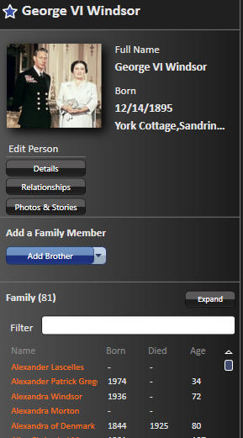
Here the gradient runs horizontally, light on the left to dark on the right. Perhaps the graphics designer thought, “I’ll make this gradient horizontal to show the user it’s a different panel used for a different reason.” Or perhaps the programmers just wanted to show how to program a horizontal gradient since they had already shown how to program a vertical one. Unfortunately, this is a really bad use of a color gradient, as bad as the vertical one is good, or maybe even worse. This is most apparent when you look at Figure 5, which shows the Photos and Stories view.

Figure 5 Photos and Stories View
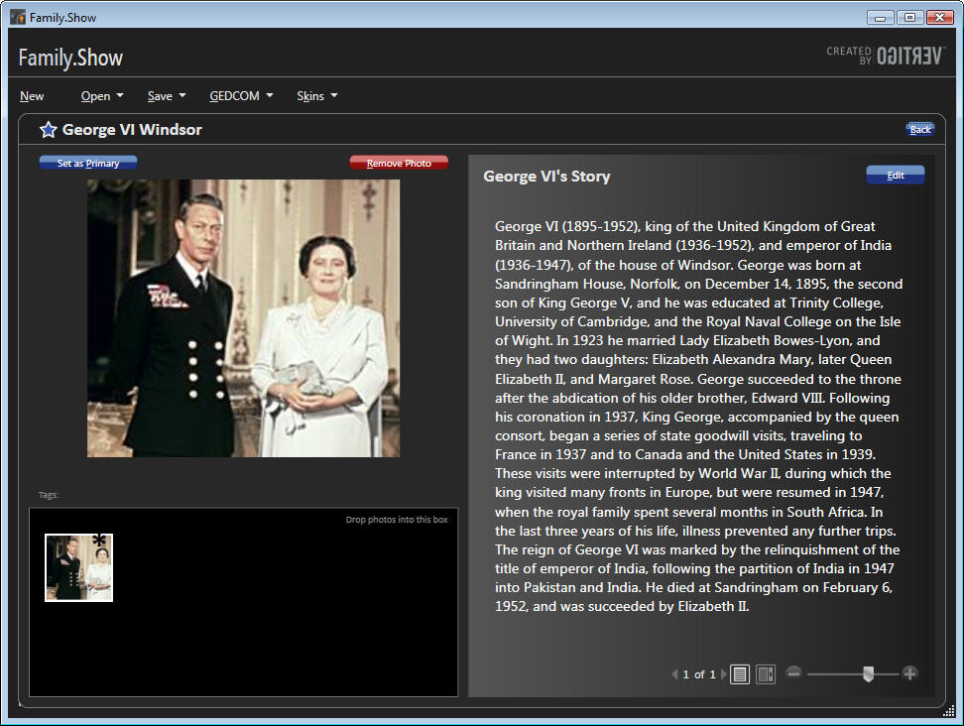
Look at the text in George VI’s story. The background is light on the left side, dark on the right. That indicates to the user’s subconscious mind that the data changes in some way as his eye moves in that direction, but this data doesn’t. There’s no difference in the meaning of the data from the beginning of the line of text to the end. This gradient is lying to the user. Not only is it lying, but it’s undermining the job done by the good gradient in the family tree panel. The user feels a tension from some parts of the program telling the truth and while others lie. That’s bad.
And it gets worse when you try to actually read the text (which is not an edge case, that’s what a user normally does with text). At the start of each line, your eye has to acquire focus on the low contrast text, white on a light gray background. We’ve been showing text in graphical environments for decades; how can anyone who claims knowledge of this domain have failed to learn that low contrast is hard to read and therefore bad? And after you’ve squinted your way to the low contrast beginning of the line, the gradient sticks the knife in. As your eye scans the text from left to right, the contrast gradually increases, and your eye has to constantly adjust, adjust, adjust to the constantly-changing contrast. Then, at the high-contrast right end of the line, your eye snaps back to the left end, has to readjust to the sudden contrast change, and then reacquire the low-contrast beginning of the next line. This gradient makes the user less happy and less productive and therefore is bad. Even a low-contrast uniform background would have been better.
When I demonstrate this application in a talk, I show this figure to my students, and say, “Start reading these lines of text and raise your hand when you feel the first pain.” The average number of lines of they can get through is about four. Try it yourself now, and see how far you get. Now compare it to Figure 6, in which I’ve replaced the gradient with a uniform background. Which can you read more quickly, and which can you tolerate for a longer time?
Figure 6 Photos and Stories View Modified to Remove Horizontal Gradient
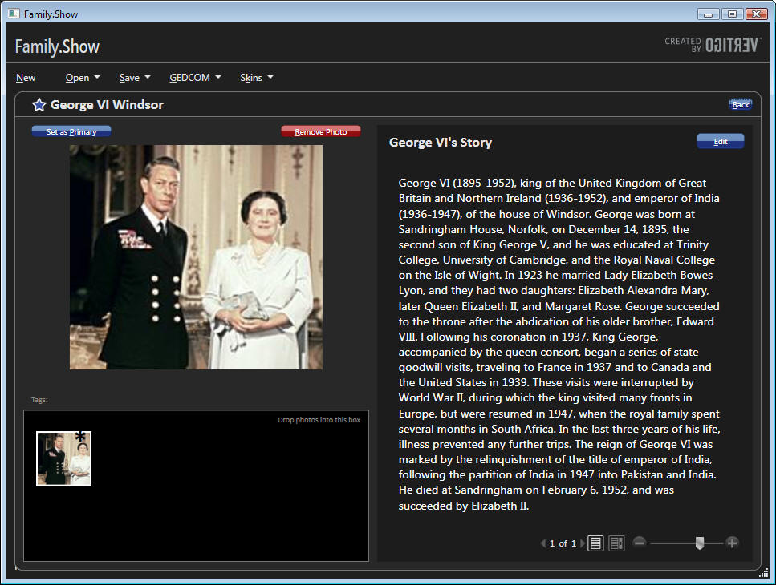
The left-hand vertical gradient gives the user good and useful information very quickly. The right-hand horizontal gradient lies to the user, and then inflicts physical pain on him in under 60 seconds. As Jeffrey Katzenberg, CEO of DreamWorks Animation, famously observed about three-dimensional movies: “Making your customers sick is not a recipe for success.”
Motion
Probably the most frequently demonstrated feature of WPF is its capacity for displaying motion. Windows couldn’t do that natively before WPF, so designers who needed motion had to use various add-on packages with all their attendant complications. Now motion is much easier to program, so it will get used more often. Should it? Or phrasing the question more precisely, under what circumstances does motion enhance a user’s throughput or pleasurable state, and therefore is good; and under what circumstances does it degrade them, and therefore is bad?
Motion attracts a user’s attention. Natural selection brutally pounded that design pattern into the human brain and visual system. Our savannah-based ancestors that noticed the twitch of the saber-tooth tiger behind the tall grass avoided being eaten and passed their attentive genes on to their descendants. The ones who didn’t notice the motion got eaten, and didn’t. Every single user is the inheritor of roughly 13,000 generations of homo sapiens who noticed motion better than the ones who didn’t make it.
There are times and places in which motion communicates ideas to the user as nothing else can. In games, for example, the tank churns around the battlefield or the pinball bounces off the bumpers. Planetarium programs show the movement of the heavens. The dishwasher serviceman’s laptop shows how to disassemble the unit, swap out a part, and put it back together. A chemical process monitor shows the rising and falling levels of reagents in the tanks and the spinning of pumps and fans. At the right time and the right place, saying the right thing to the right user, it’s absolutely fabulous, life-and-death important. It’s another mainline into the user’s brain, in the same manner as the color gradient, but even more powerful.
Precisely because of this power, it shouldn’t surprise you that misused motion can harm the user experience more than anything else. Imagine if the clock at the lower right corner of the Windows task bar showed the seconds digits ticking away. Most users would find that disquieting. On a telephone application such as Skype, where you pay by the minute, perhaps; but not on the main task bar that you stare at all day every day. Now suppose it also showed tenths of seconds spinning madly away. That’s even worse. On a stopwatch application, perhaps; but not on the main task bar. No one could ever get any work done. As user interface expert Jared Spool wrote of his test of a Disney web page containing an animated logo, that corporate branding icon so beloved of marketeers everywhere: “Users first tried to scroll the animation off the page, and when they couldn’t, actually covered it up with their hands so they could read the rest of the text.” I would have paid money – in fact, would still pay money – to see him show the video of that test to the president of Disney. He’d probably strap the designer into a straitjacket and force him to ride “It’s a Small World After All” for two solid days before allowing him to drown himself. A designer that says, “users will just ignore motion that they don’t like,” does not understand the human animal.
If you look at my list of scenarios that use motion well, you’ll see that they use motion on the display screen to represent motion in the world (real or imaginary) to the user. In a line-of-business, data entry and viewing application such as FS, though, the case for motion is less obvious. Designers strive mightily to shoehorn it in somewhere, desperate to play with the shiny new toy in their toolbox and appear cool to their peers and their own self-images, but its benefit to the user is much harder to find in this kind of application. Family trees don’t change that often, and realtime tracking is rarely necessary.
Figure 7 shows Vertigo’s list of “10 Things We Learned” in writing this application. Number nine is “You get one gratuitous animation effect per application.” No, you don’t. Dictionary.com defines the ‘G’ word as “being without apparent reason, cause, or justification: a gratuitous insult.”

Figure 7 Vertigo's List of 10 Things We Learned
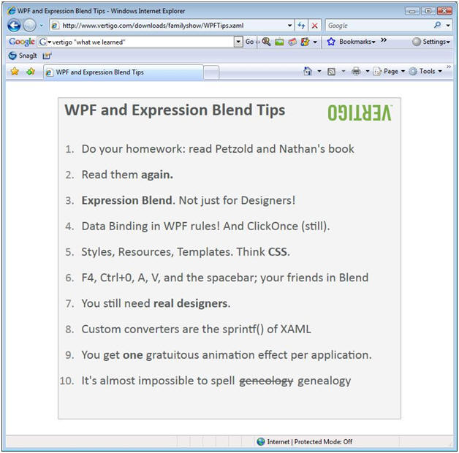
I’m sorry, but that’s not acceptable to inflict on a user. As with the color gradient, you are bypassing the user’s socialized, rational left brain and reaching deep into his right brain, in a much more intimate way than computer programs ever did before. Your program’s motion triggers a user’s saber-tooth tiger detection mechanism. To misuse this communication channel is to disrespect the user. They won’t tolerate it, and shouldn’t be asked to. And from a purely mercenary standpoint, it’s too powerful to waste. Let’s see how FS uses motion.
When you click on a person in the family tree pane, FS highlights that person and shows additional information about him in the details pane on the right. FS uses effective highlights to indicate the selectee, a larger icon and a circle and a star (Figure 8). This pattern of selection and detail views is common to many Windows applications. The selection view in FS is larger and the details view smaller than usual, but the shape of a family tree requires that ratio, and the user takes it in without a problem. So far, so good.
Figure 8 Highlighting of Selected Person
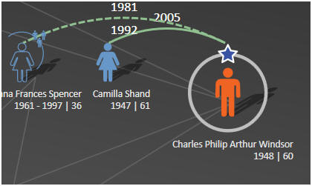
In addition to displaying the selectee’s details, FS moves people around to different locations on the family tree. The selected person moves to the rightmost end of his generation’s line, placing him next to the details pane. I find this confusing on two levels. First, the thing that I clicked on jumped away from me, which is the last thing any user expects. I can’t immediately think of another program in which that happens, other than one I wrote as a joke in my misspent youth. It was hysterically funny, for about three seconds. I’m afraid I can’t repeat my boss’s language after the second time my program did that to him. Second, a family tree usually shows siblings in order of age, from left to right or occasionally right to left. When the selectee moves, this order becomes scrambled for that generation line. Usually George VI is next to his younger sister Mary, but if he’s selected, he moves to the right end and Edward VII is next to Mary. Moving the selected person to the right end confuses the picture more than it clarifies it.
After transferring the selectee to the right end of the generation line, FS closes the previous selectee’s descendants and opens as many of the new selectee’s descendants as it has room for. This makes sense. The user selected a particular person because he wanted to see more information about him, and the descendant tree is the most important piece of that information. This changes the size of the displayed family tree, often by a large amount. George VI has three levels of descendants, maybe four if the rumors about Prince Harry are true; Edward VIII has none. FS now runs an animation in which the new family tree slides into the center of the pane from one of the edges. Again, I find this confusing. The tree slides in from different edges of the pane without apparent rhyme or reason; sometimes from the bottom, sometimes the top, sometimes the left; sometimes more or less orthogonally, sometimes diagonally. If you click Edward VIII, it slides in from the upper left, but if you click his younger brother George VI, it slides in from the lower left. I thought it might have had something to do with the presence of children (George had two, Edward none), but if you click on Edward’s wife Bessie Wallis Warfield (no children), it slides in from the lower right. In addition, the center of the new tree, both horizontally and vertically, moves to the center of the tree display pane. That may sound logical as you read it, but this often causes the selectee’s generation line to move up or down from where it was when the user clicked on it. And nothing else is where it used to be either, because the selectee’s ancestors move up or down as well. I clicked on a person because I wanted to see that person’s details, not because I wanted to reconfigure the entire display. Now I have to visually reacquire the entire tree and visually reorient myself. The motion scrambles my mental picture, every single time. And it gets worse.
I said above that the last thing that any user expects when he clicks on something is that it’ll slide away from him. I need to retract that statement. There’s one thing in the world that the user is expecting less. And that is for the item that he’s clicked on to disappear entirely. Yet that’s what sometimes happens with FS’s re-centering animation. The selectee’s details appear in the details pane, but switching the selectee to the right end and then re-centering the tree sometimes causes the selectee to slide out of sight under the details pane. In Figure 9, you can see George VI in the details pane, you can see his wife in the tree view, but you can’t see him on the tree view. He slid out of sight, under the details pane, when I selected him. If that’s not a violation of the Principle of Least Astonishment, I don’t know what is.

Figure 9 Selected Person Scrolled Off Screen by Automatic Re-centering
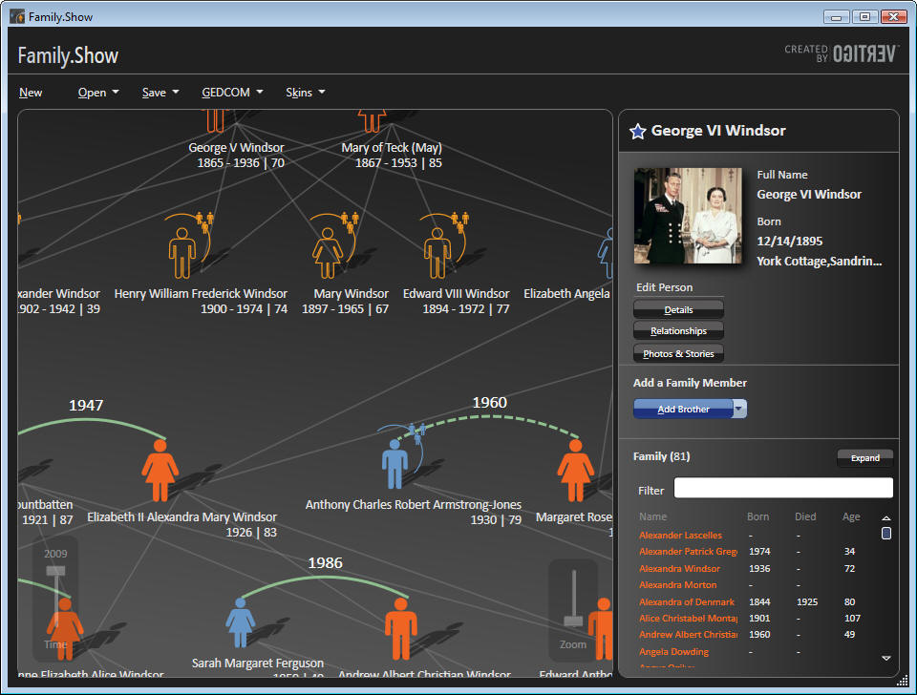
What do you think the user says to himself when the family tree slides around? Does he say, “Wow, it moved! How cool! I’m using the latest technology, hot diggety dog, life is good! Do it again, will ya?” Or does he say, “Hey, I just clicked on this guy and he disappeared. What the hell?” I can just see the tech support person answering the phone call: “I clicked on this guy, and he disappeared! No, I DIDN’T press delete! Where the [expletive] did he go? … Only two drinks, why do you ask?”
When I looked into the source code, the direction of the motion comes from the internal organization of the family tree and the display pane inside the program. It doesn’t have anything to do with expressing meaning to the user. Yet motion cannot help but scream into a user’s brain and trigger a search for meaning (“where’s that tiger?”), causing internal frustration if none can be found. If you don’t believe me right now, think how annoyed you get on the highway when you’re following a car whose driver has left his turn signal on. Clearly, Vertigo wanted to demonstrate how one went about programming motion into an application, not to demonstrate the motions that would make a user happier or more productive.
What sort of motion would make a user happier in this situation? Opening the selected person in place would be a better idea. The selectee is shown with a larger icon, perhaps its size could smoothly increase with a very short animation, not more than one or two tenths of a second. The icon would seem to move towards the user, thereby reinforcing the message of selection. The previous selectee would shrink back to normal size, hence appearing to move away from the user, again reinforcing the new selection. Perhaps the siblings on either side would slide to the left or right to make room for the larger icon of the selectee, maintaining the left-right sibling order which does carry a meaning. The descendants of the previous selectee would be closed and those of the current selectee opened. Nothing would change on the levels above the selectee, and the user wouldn’t have to reacquire the entire tree.
This design would use a whole lot less motion, but that small amount of motion would carry genuine meaning into the user’s brain. I don’t see how it makes a user happier or more productive to see a large amount of randomly varying motion that even its creator describes as gratuitous.
Re-Looking of Controls
WPF’s architecture separates a control’s behavior from its appearance. A designer can radically alter a control’s visual appearance in XAML without changing its behavior, an action called “re-looking” a control, or sometimes “skinning” the control. As is the case with the rest of my examples, FS handles the re-looking of controls well in some cases, and not so well in others.
For the done-well, look at the people on the family tree view, back in Figure 8. This small picture conveys a lot of information to the user. The shape tells you male or female, the fill tells you whether they’re alive or dead, the color specifies a blood relationship versus a marital relationship and so on. The arched line shows a marriage, invoking an arm around a shoulder, dashed for previous, solid for current. The current selectee is shown larger, with a circle around it and a star on top, naturally grabbing your eye. Again, these symbols speak quickly to the right side of the user’s brain. If the only indicator of a person’s sex were the letters M or F, you’d have a much harder time getting them into your brain.
Besides using these pictures for display, FS needed to make them clickable. If each picture had a regular button below it for selecting it, the tree display would have been much busier and harder to grasp. If you look at the source code, you’ll find that Vertigo has implemented the clickable pictures by re-looking the button control – the class DiagramNode derives from Button. It required a lot of XAML from a designer, but surprisingly little C# code. Along with that good symbolic representation, the clicking behavior is exactly that of the button from which it derives, as are its other properties – for example, highlighting when the mouse hovers over it, popping up a tooltip after a delay, and so on. The user doesn’t know that the node is actually a button inside, doesn’t want to know, shouldn’t be and isn’t asked to know. The user thinks he’s clicking on a person, and he is. This is a really good example of what you can accomplish by changing the look of a control and inheriting its previous behavior.
On the other hand, look at the buttons that look like regular buttons, such as Figure 10. The graphic designer got, IMHO, a little too fancy here. The top of the button differs in color from the bottom for no apparent reason. The low contrast between the bottom of the button and its background makes it hard to see where to click. The low contrast between the white text and the light-blue top is hard to read, and the abrupt change in contrast between the lower and upper halves of the button makes it harder. It’s a little better in the silver skin because the three-d effect happens at the bottom of the button and there isn’t a mid-line cutting through the text (Figure 11), but the contrast is still low, and the fonts are small and slender. And the contrast of the menu buttons, dark gray text on a medium-dark gray background (Figure 12), is terrible.
Figure 10 Figure 11 Figure 12
Black skin button Silver skin button Silver Skin Menu Button
.
In the Channel 9 interview of the design team, the creative designer looks barely old enough to shave, and the CEO isn’t that much older, he still seems to have all his hair. This app was written for young eyes. The buttons that look like and actually are buttons need to be done differently, as you’ll see when you think about who the users of genealogy applications actually are. To those neglected users we now turn our attention.
Thinking About Users
Platt’s First, Last, and Only Law of User Experience Design states, “KNOW THY USER, FOR HE IS NOT THEE.” Unless you are writing applications for the use of burned out computer geeks, your user is not you. They are very, very different from you, in ways that are hard for you even to imagine. So who are the users of genealogy applications?
Short answer: older people. I had a long discussion about his customer base with a client of mine who works on commercial genealogy applications. I’m not allowed to give specific breakdowns, but essentially none of their users are younger than 50 years old, and many of them are much older. Genealogy is the fastest growing hobby today precisely because this is the fastest growing age group. Young people are much more interested in finding a partner with whom to create descendants than in writing down their ancestors. Only as they cross the watershed of half a century, with children out of the house and grandchildren at least on the horizon, childhood pets dead or at least doddering, do people start thinking about leaving a record for posterity. Not until they; we; dammit, I ; feel that first chill breeze of mortality do we start agreeing with poet and funeral director Thomas Lynch, who wrote thusly about his wishes for his own funeral: “All I really wanted was a witness. To say I was. To say, daft as it still sounds, maybe I am.” That’s why people buy and use genealogy software, and that’s the stage in their lives when they start doing it. If you think a flashier genealogy application would tempt 20-somethings out of the dance bars on a Saturday night, you’ve forgotten your own 20-something years.
What do older people like and dislike in their applications? What makes them happier or less happy compared to what pleases or doesn’t please younger users? For starters, older users have trouble with near vision, as the lens of the eye loses its elasticity with age. The ability to focus on near objects drops from about 10 diopters in a young adult to about 1 diopter by age fifty. Essentially every user of this application is in a large-print stage of life, although few of us like to admit it. The subconscious right-brain cues, such as the color gradients and the person outlines, become even more important as the reading of text gets harder. Conversely, obstacles to reading text, such as the horizontal color gradient or low contrast or small fonts, get even more obstacular.
It’s not only the physical requirements of this audience that an application designer needs to consider. This audience has different mental requirements as well. The president of a senior citizen user group to whom I recently spoke wrote me that [capitals hers, italics mine], “PLEASE remember that as seniors, we hear and digest things slower than young adults. You MUST speak slower than you would if presenting to a younger group.” Imagine how confusing the constant repositioning of the selected person and the re-centering of the family tree must be for this user population. Conversely, think how helpful a smaller, consistent, easily understood piece of motion would be. The age of the user population amplifies both good and bad design choices – the good symbolic communication that FS does becomes even better, and the bad communication gets even worse.
Look at Figure 7 again, “Things We Learned.” Every single one of them discusses how to implement this or that feature of WPF. Not one of them deals with any notion of who the user is, what problems the user is trying to solve, what pleasurable state the user wants to enter. It contains nothing about what the user loves, what the user hates, what the user is willing to tolerate, what the user can and can’t do; how we’re going to please the user in order to separate him from his money. The “U” word does not appear, not even once. And that, my friends, is what needs to change in today’s software world. We need to work from the user inward, not from the toolkit outward. Because the same technology that can delight the user can also infuriate him, and vice versa.
Conclusions
WPF provides a completely different way of communicating with the user of a computer program, as different from the text-based Windows Forms as video is from audio, as different as parallel is from serial. This difference in requires changes in the thinking of designers and architects and programmers.
As a chain saw is more powerful than a hand saw, both for good and for evil, so WPF is more powerful than WF, both for good and for evil. As we have to be more careful and skillful with a chain saw to produce the results that we want (a full cord of firewood cut in an afternoon) without the bad consequences that we don’t want (someone’s leg chopped off in a second), so we have to be more careful and skillful with WPF. The power is widely recognized; the concomitant need for care and thought is not, and it needs to be.
The Family.Show sample application provides excellent instruction on how to employ implement various parts of WPF. It also shows, probably unintentionally, how the same WPF feature can both help and harm a user’s experience, depending on the time and place and manner in which that feature is used.
Author Bio
David S. Platt teaches Programming .NET at Harvard University Extension School and at companies all over the world. He is the author of eleven programming books. His Introducing Microsoft .NET from Microsoft Press introduced thousands of programmers to that environment. Even today, 5 years after its most recent release, it is outselling Tom Clancy’s Every Man a Tiger on Amazon.com, which tells you what kind of geeks buy their books there. His magnum opus, Why Software Sucks (Addison-Wesley, 2006, www.whysoftwaresucks.com), points out ways in which software MUST improve if it’s to accompany humanity into the twenty-first century. He is famous for his engaging presentation style. "He’s the only guy I know that can actually make a talk on COM’s apartment threading model funny," said one student. Microsoft named him a Software Legend in 2002.
Dave holds the Master of Engineering degree from Dartmouth College. He did his undergraduate work at Colgate University. When he finishes working, he spends his free time working some more. He wonders whether he should tape down two of his daughter’s fingers so she learns how to count in octal. He lives in Ipswich, MA.
Nickname: "The Mad Professor"
Favorite Web Site: www.radomargaritaville.com
Comment most frequently elicited from children at adjoining breakfast restaurant tables before he’s had his morning coffee: "Mommy, what’s wrong with that man?"

See, for example, http://www.youtube.com/watch?v=PMseEKzkQho (warning: graphic).
Anyone interested in further examples of using color gradients to present useful information very quickly will like Vanderbei’s page http://www.princeton.edu/~rvdb/JAVA/election2004/. He shows similar charts for other elections as well. For example, you can see how the South and West favored Jimmy Carter in 1976 over Gerald Ford, and how the South stayed true to Carter but the West defected to Ronald Reagan in 2000. He adds green to show the effect of George Wallace’s third-party run in 1968, and so on. It is extremely well done.
Yes, there are always obscure edge cases in which low-contrast text is necessary – interpretive signs in a historically furnished museum room, for example, where you need text to explain what the visitor is seeing without intruding on the experience. We’re not even close to that situation here.
For a good discussion of the technical aspects of eye pain as they relate to typography, see Jim Sheedy and Kevin Larsen’s article at http://www.eyemagazine.com/opinion.php?id=157&oid=414 .
Jared Spool et. al. Web Site Usability: A Designer’s Guide. Morgan Kaufman, 1999. Page 89.
The Principle of Least Astonishment states simply that astonishing the user rarely makes him happy, so you want to do it as seldom as possible.
See, for example, the clip from my keynote talk at http://www.youtube.com/watch?v=JAOTTLQ0rlY , discussing the differences between programmers and their users.
My late grandmother’s favorite joke tells of a priest, a minister, and a rabbi debating the moment at which life begins. The priest smacks his hand down on the table and says, “There’s no debate. His Holiness has declared with papal infallibility that life absolutely begins at conception.” The minister says, “Not so fast, brother priest. We ministers read our Bibles and attend our conferences and participate in Internet discussion groups, and through our justification by faith alone, we’ve more or less come to the general consensus that life begins at birth.”The rabbi says, “You goyim [gentiles] you’re all meshuggeneh [crazy]. Our greatest scholars have studied the Talmud and the wisdom of the ancient rabbis, and come to the inescapable conclusion that life begins when the kids are through school and the dog has died.”
Lynch, Thomas. The Undertaking: Life Studies From the Dismal Trade. Penguin, 1997, pg 199.
http://en.wikipedia.org/wiki/Presbyopia
There’s a good example in this very paragraph. You probably took in the short phrase “capitals hers, italics mine” at the beginning of this quote with no trouble at all. I tried it on several healthy, educated, literate seventy year old people, and every one of them had to parse it a few times to figure out what I meant and decide if it mattered. If I didn’t need it to make this point, I’d go back and rework it.

